**NAME:** MUHAMMAD UZAIR

**NUMBER:** 0323-3358701

**COURSE:** WD-II

**Web Assignment 1**

**Github Repository link:** <https://github.com/MuhammadUzair4/assignment.3>

**Create three assignments**

**1. Create a 3 page website using flexbox**

**Ans:**

**//main.html**

<!DOCTYPE html>

<html lang="en">

<head>

<meta charset="UTF-8">

<meta name="viewport" content="width=device-width, initial-scale=1.0">

<link rel="stylesheet" href="style.css">

<title>Flexbox Website</title>

</head>

<body>

<header>

<h1>Flexbox Website</h1>

</header>

<nav>

<ul>

<li><a href="page1.html">Page 1</a></li>

<li><a href="page2.html">Page 2</a></li>

<li><a href="page3.html">Page 3</a></li>

</ul>

</nav>

<main>

<p>Welcome to the Flexbox website! Click on the links above to navigate through the pages.</p>

</main>

<footer>

<p>&copy; 2024 Flexbox Website. All rights reserved.</p>

</footer>

</body>

</html>

**//page1:**

<!DOCTYPE html>

<html lang="en">

<head>

<meta charset="UTF-8">

<meta name="viewport" content="width=device-width, initial-scale=1.0">

<link rel="stylesheet" href="style.css">

<title>Page 1</title>

</head>

<body>

<header>

<h1>Page 1</h1>

</header>

<nav>

<ul>

<li><a href="index.html">Home</a></li>

<li><a href="page2.html">Page 2</a></li>

<li><a href="page3.html">Page 3</a></li>

</ul>

</nav>

<main>

<p>This is Page 1 content.</p>

</main>

<footer>

<p>&copy; 2024 Page 1. All rights reserved.</p>

</footer>

</body>

</html>

**//page2:**

<!DOCTYPE html>

<html lang="en">

<head>

<meta charset="UTF-8">

<meta name="viewport" content="width=device-width, initial-scale=1.0">

<link rel="stylesheet" href="style.css">

<title>Page 2</title>

</head>

<body>

<header>

<h1>Page 2</h1>

</header>

<nav>

<ul>

<li><a href="index.html">Home</a></li>

<li><a href="page1.html">Page 1</a></li>

<li><a href="page3.html">Page 3</a></li>

</ul>

</nav>

<main>

<p>This is Page 2 content.</p>

</main>

<footer>

<p>&copy; 2024 Page 2. All rights reserved.</p>

</footer>

</body>

</html>

**//Page3:**

<!DOCTYPE html>

<html lang="en">

<head>

<meta charset="UTF-8">

<meta name="viewport" content="width=device-width, initial-scale=1.0">

<link rel="stylesheet" href="style.css">

<title>Page 3</title>

</head>

<body>

<header>

<h1>Page 3</h1>

</header>

<nav>

<ul>

<li><a href="index.html">Home</a></li>

<li><a href="page1.html">Page 1</a></li>

<li><a href="page2.html">Page 2</a></li>

</ul>

</nav>

<main>

<p>This is Page 3 content.</p>

</main>

<footer>

<p>&copy; 2024 Page 3. All rights reserved.</p>

</footer>

</body>

</html>

**//Styles.css:**

body {

font-family: 'Arial', sans-serif;

margin: 0;

padding: 0;

box-sizing: border-box;

}

header, nav, main, footer {

margin: 20px;

padding: 20px;

}

header {

background-color: #3498db;

color: #fff;

text-align: center;

}

nav {

background-color: #2ecc71;

color: #fff;

}

nav ul {

list-style-type: none;

display: flex;

justify-content: space-around;

}

nav a {

text-decoration: none;

color: #fff;

}

main {

flex: 1;

}

footer {

background-color: #e74c3c;

color: #fff;

text-align: center;

}

**Output:**

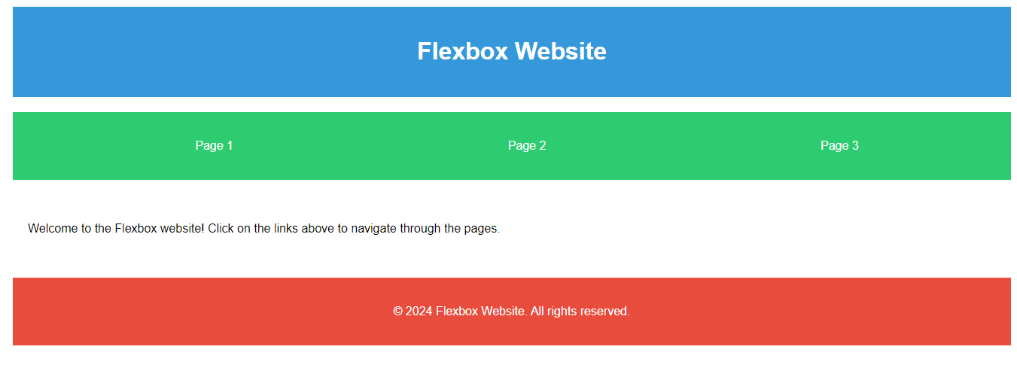

**2. Create 3 pages website using grid**

**Ans:**

<!DOCTYPE html>

<html lang="en">

<head>

<meta charset="UTF-8">

<meta name="viewport" content="width=device-width, initial-scale=1.0">

<title>Grid Website</title>

<style>

body {

font-family: 'Arial', sans-serif;

margin: 0;

padding: 0;

box-sizing: border-box;

}

.grid-container {

display: grid;

grid-template-areas:

"header"

"nav"

"main"

"footer";

min-height: 100vh;

}

header {

grid-area: header;

background-color: #3498db;

color: #fff;

text-align: center;

padding: 20px;

}

nav {

grid-area: nav;

background-color: #2ecc71;

color: #fff;

padding: 20px;

}

nav ul {

list-style-type: none;

display: grid;

grid-template-columns: repeat(3, 1fr);

gap: 10px;

}

nav a {

text-decoration: none;

color: #fff;

text-align: center;

padding: 10px;

border-radius: 5px;

background-color: #27ae60;

}

main {

grid-area: main;

padding: 20px;

}

footer {

grid-area: footer;

background-color: #e74c3c;

color: #fff;

text-align: center;

padding: 20px;

}

</style>

</head>

<body>

<!-- Page 1 -->

<div class="grid-container">

<header>

<h1>Page 1</h1>

</header>

<nav>

<ul>

<li><a href="#">Home</a></li>

<li><a href="#">Page 2</a></li>

<li><a href="#">Page 3</a></li>

</ul>

</nav>

<main>

<p>This is Page 1 content.</p>

</main>

<footer>

<p>&copy; 2024 Page 1. All rights reserved.</p>

</footer>

</div>

<!-- Page 2 -->

<div class="grid-container">

<header>

<h1>Page 2</h1>

</header>

<nav>

<ul>

<li><a href="#">Home</a></li>

<li><a href="#">Page 1</a></li>

<li><a href="#">Page 3</a></li>

</ul>

</nav>

<main>

<p>This is Page 2 content.</p>

</main>

<footer>

<p>&copy; 2024 Page 2. All rights reserved.</p>

</footer>

</div>

<!-- Page 3 -->

<div class="grid-container">

<header>

<h1>Page 3</h1>

</header>

<nav>

<ul>

<li><a href="#">Home</a></li>

<li><a href="#">Page 1</a></li>

<li><a href="#">Page 2</a></li>

</ul>

</nav>

<main>

<p>This is Page 3 content.</p>

</main>

<footer>

<p>&copy; 2024 Page 3. All rights reserved.</p>

</footer>

</div>

</body>

</html>

**Output:**

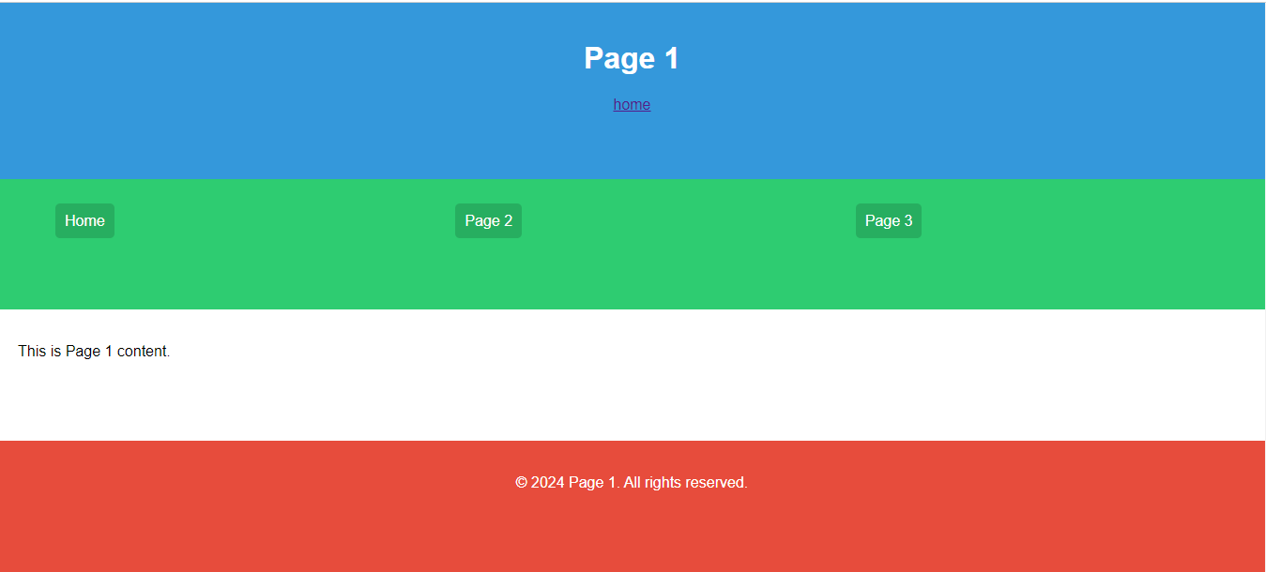

**3. Create a Todo List using HTML5 CSS3 and JavaScript**

**Ans:**

<!DOCTYPE html>

<html lang="en">

<head>

<meta charset="UTF-8">

<meta name="viewport" content="width=device-width, initial-scale=1.0">

<title>Todo List</title>

<style>

body {

font-family: 'Arial', sans-serif;

margin: 0;

padding: 0;

box-sizing: border-box;

background-color: #f4f4f4;

}

#todo-container {

max-width: 400px;

margin: 50px auto;

background-color: #fff;

border-radius: 5px;

box-shadow: 0 0 10px rgba(0, 0, 0, 0.1);

}

h1 {

text-align: center;

color: #333;

padding: 20px 0;

}

input[type="text"] {

width: 80%;

padding: 10px;

margin: 10px;

border: 1px solid #ccc;

border-radius: 3px;

}

button {

background-color: #4caf50;

color: #fff;

padding: 10px;

margin: 10px;

border: none;

border-radius: 3px;

cursor: pointer;

}

ul {

list-style-type: none;

padding: 0;

}

li {

display: flex;

justify-content: space-between;

align-items: center;

border-bottom: 1px solid #ccc;

padding: 10px;

}

li:last-child {

border-bottom: none;

}

.delete-btn {

background-color: #e74c3c;

color: #fff;

padding: 5px;

border: none;

border-radius: 3px;

cursor: pointer;

}

</style>

</head>

<body>

<div id="todo-container">

<h1>Todo List</h1>

<input type="text" id="todo-input" placeholder="Add a new todo">

<button onclick="addTodo()">Add Todo</button>

<ul id="todo-list"></ul>

</div>

<script>

function addTodo() {

const todoInput = document.getElementById("todo-input");

const todoList = document.getElementById("todo-list");

if (todoInput.value.trim() !== "") {

const li = document.createElement("li");

li.innerHTML = `

<span>${todoInput.value}</span>

<button class="delete-btn" onclick="removeTodo(this)">Delete</button>

`;

todoList.appendChild(li);

todoInput.value = "";

}

}

function removeTodo(button) {

const todoList = document.getElementById("todo-list");

const li = button.parentElement;

todoList.removeChild(li);

}

</script>

</body>

</html>

**Output:**

